SAP

Learn-008

Enterprise application ca

Daire O’Neill

Objectives:

The objective of this CA is to put myself in the shoes of an employee working in sales in GBI Germany, and to sell to a customer, Alster Cycling.

During this CA we learn that one of our materials is out of stock, so we must buy them from one of our German suppliers in order to meet the sales order.

I opened SAP then went through the following folders.

Alster Cycling

Customer ID: 14008

Customer Address: 20249 Hamburg

I was brought to this screen where I entered my number 008 as a search term in order to find my customer.

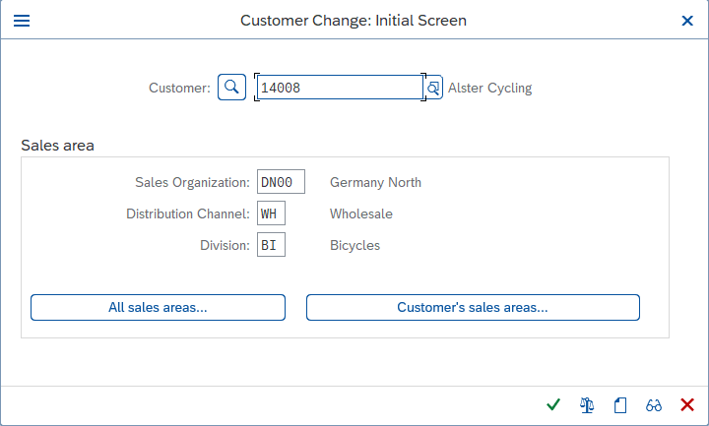

I changed the sales district to North Germany (DE0001),

The customer group to industry (01)

I changed the BP role to defined

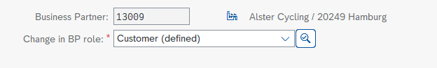

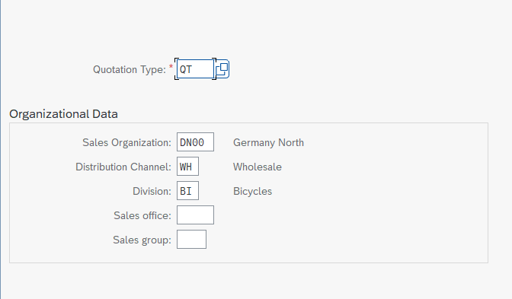

I created a new quotation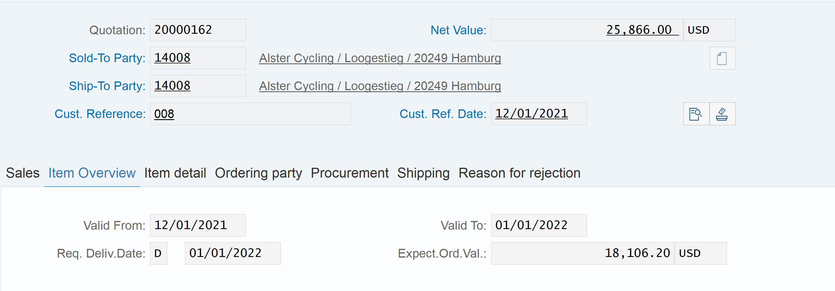

I adjusted the dates to be one month in advance from request delivery date.

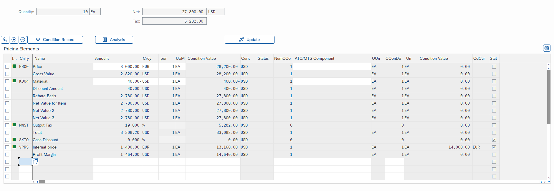

I then gave a $40 discount on the off the deluxe bikes as well as 10% on the whole order.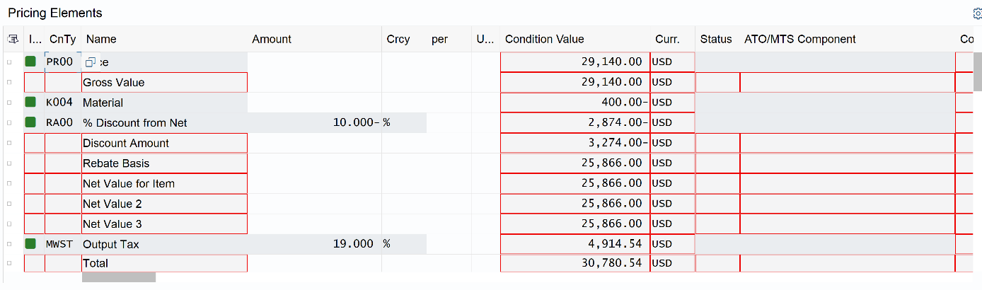

The net amount for the quotation is 30,780.54 USD.

I then saved the quotation

(20000278) new quotation

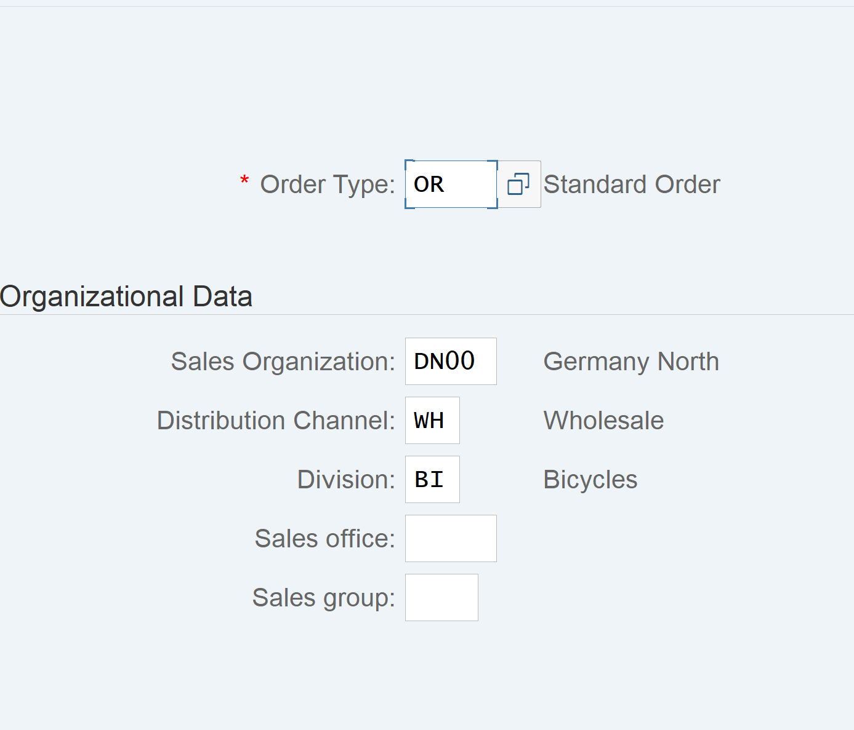

I then created the standard order with reference

I proceeded to input my invoice number and select copy. I was then given this screen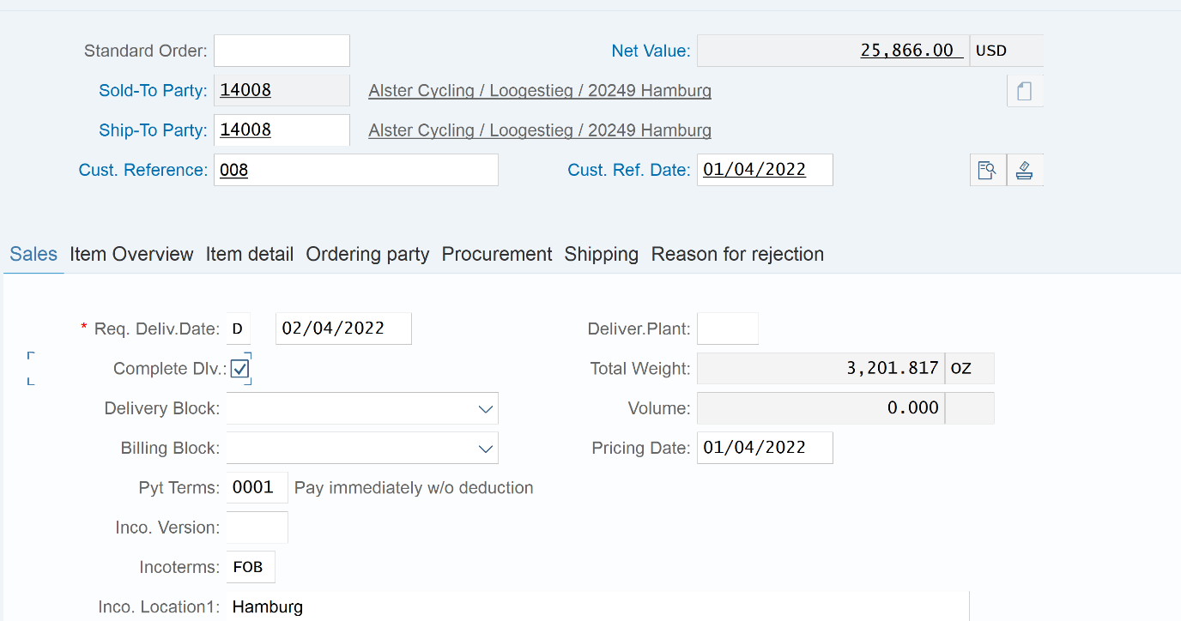

I filled in the cust reference, cust ref date and ticked confirm stock availability to confirm delivery and saved

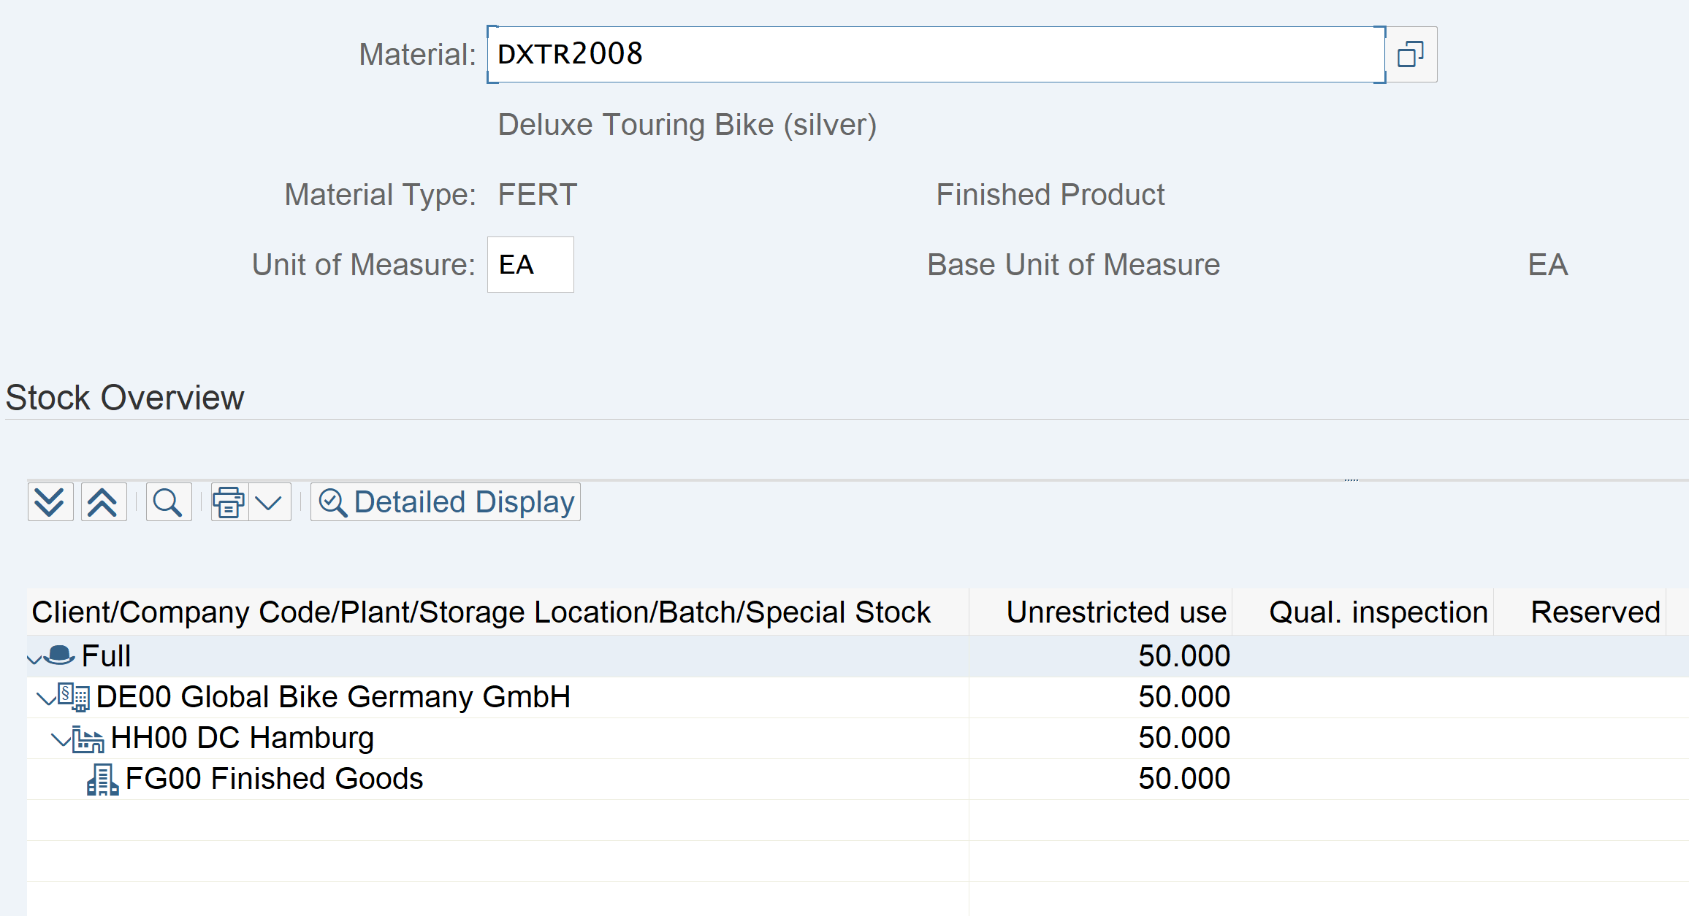

I searched the stock for silver deluxe bikes and found we had 50 in stock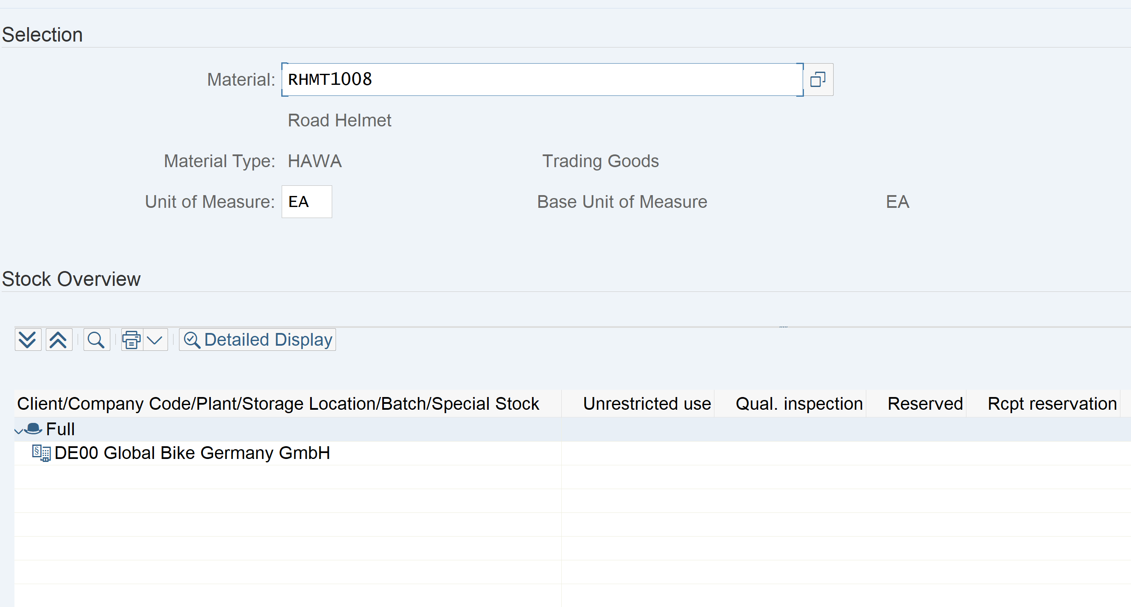

I then searched for the road helmet stock but none were in stock, so this order isn’t able to be delivered immediately.

Since I’m missing materials, I need to buy some so I created a purchase order.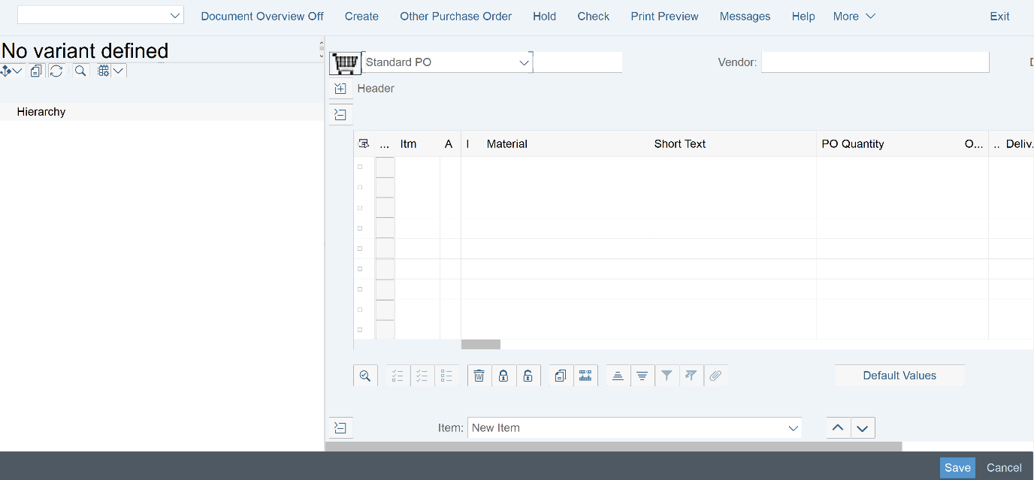

I then enter the material, vendor, quantity, net price of material, the delivery date and the org levels.

I then saved the purchase order.

The total amount for the purchase order was 1,250 USD

I then created a goods receipt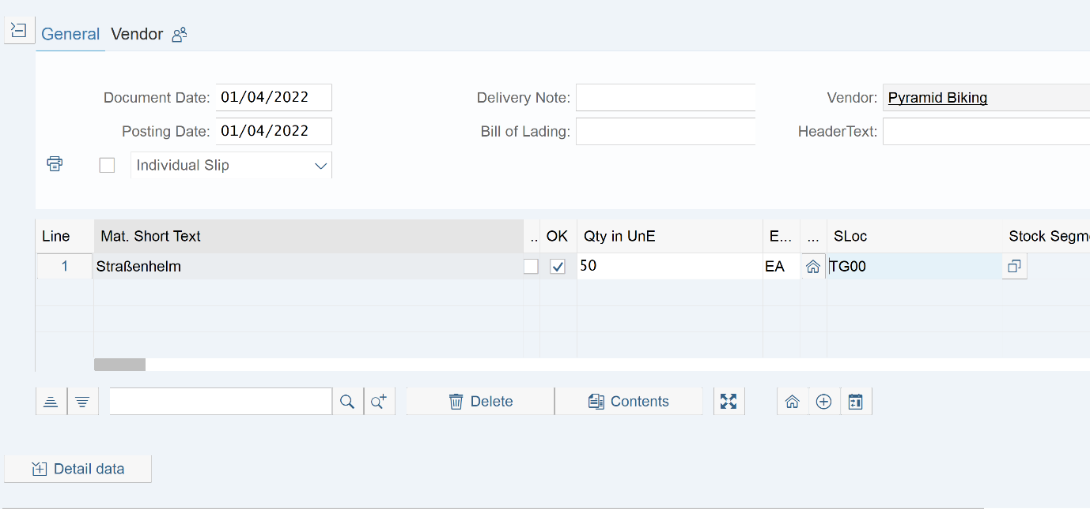

I filled in Slock and ticked ok and then post

I then checked my stock and found that the 50 helmets were now in stock.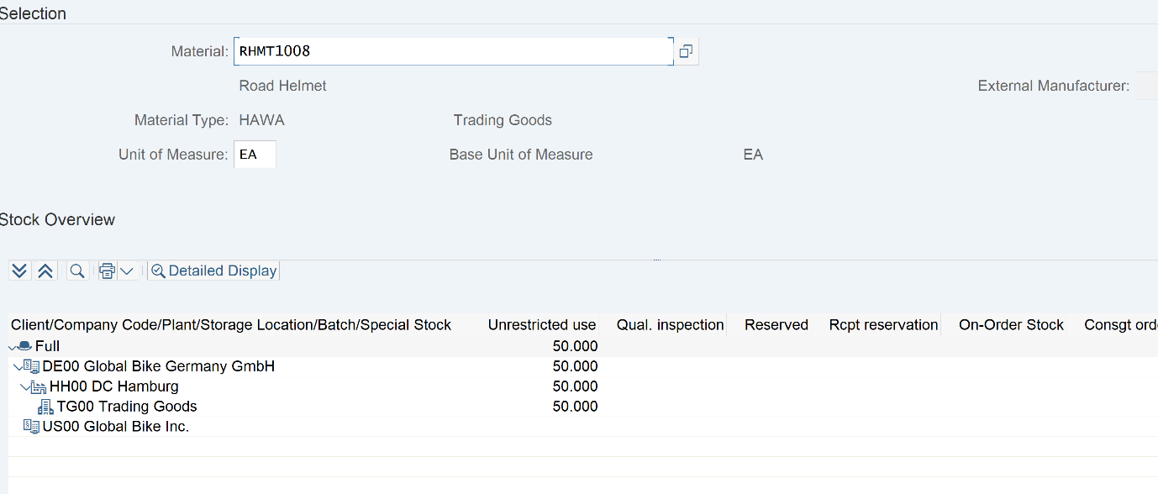

I then created an invoice receipt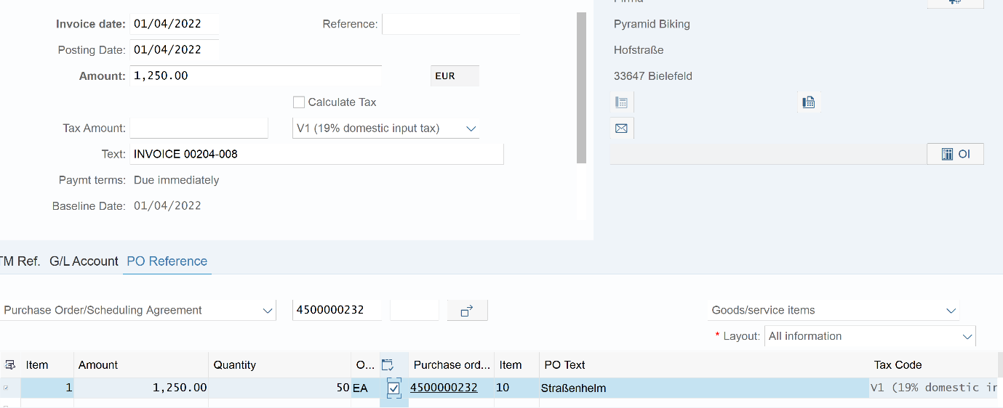

I then added the company code, the amount, the dates and the text. I also ticked the booking ok and finally post.



I then posted payments to vendor.

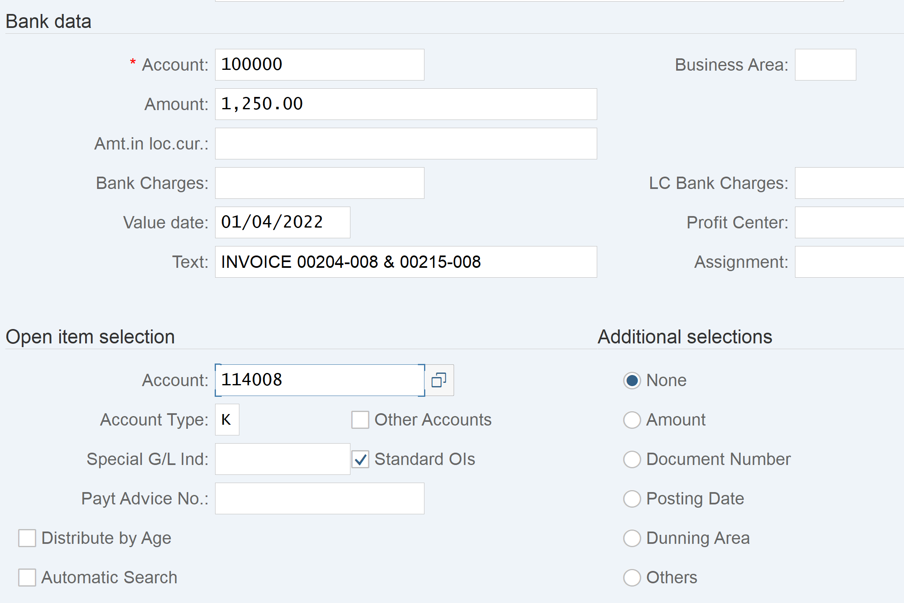

I entered the account, amount, account and text and the posted

I post good issue to Alster Cycling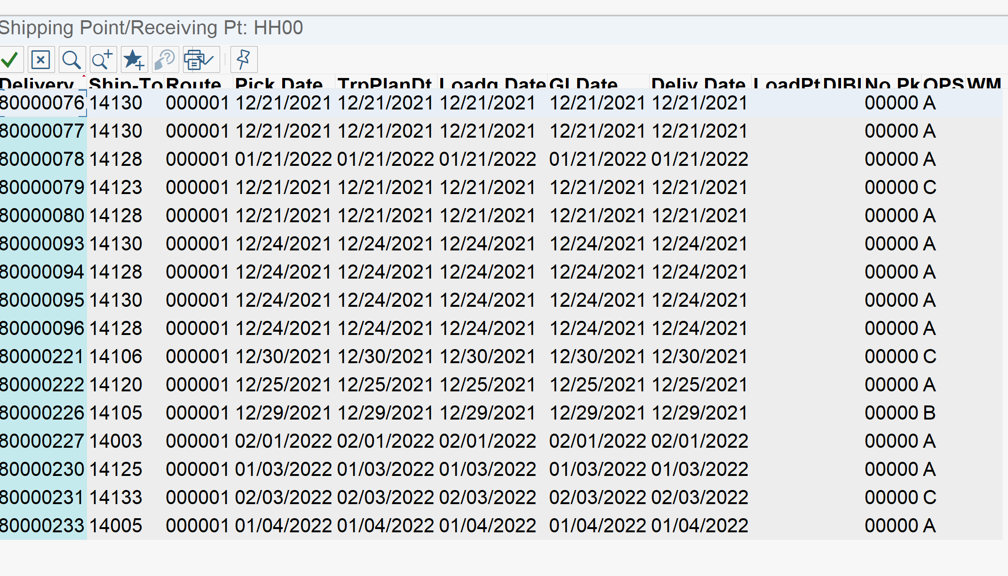

Unfortunately I couldn’t find anything relevant to me

I then did a stock check but nothing had sent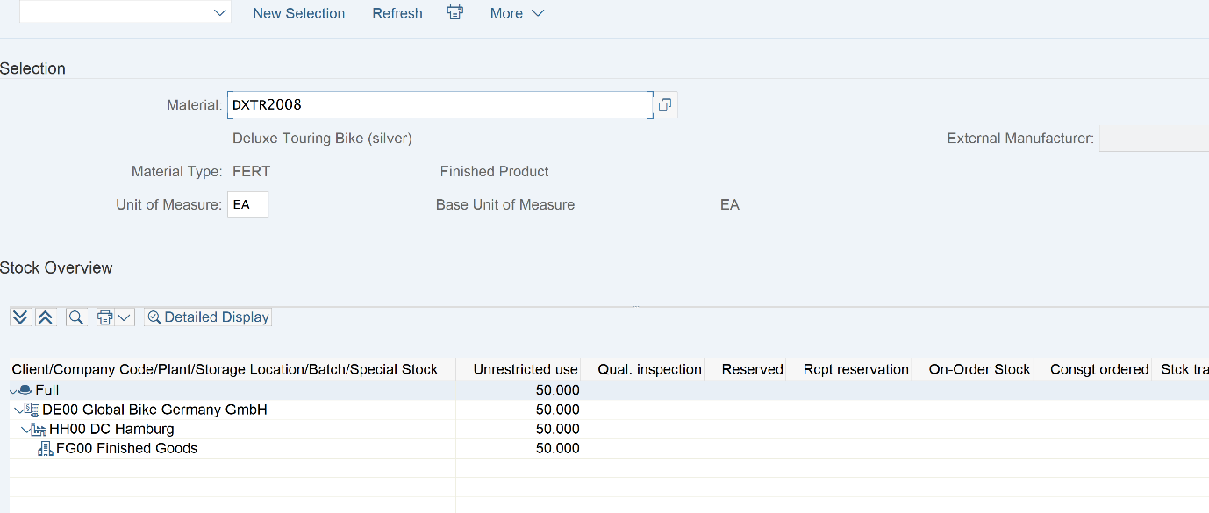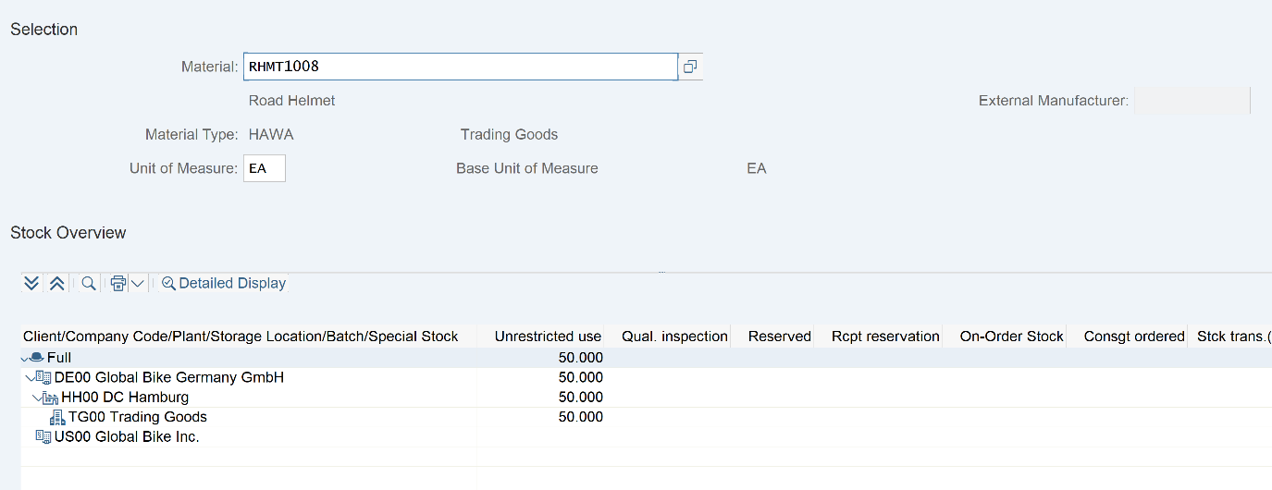

Limitations:

Enough time had passes since I created the original quotation so I had to create another one in order to continue with the CA. The only other limitations were with navigating the menus in order to find submenus like plan delivery or display document flow.

Conclusion:

This was a good example of using SAP in a real-life scenario. While not the most intuitive software, this shows how all elements of a business come together, with information on different storage plant, as well as accounting, stock management and many more being available on the same software. I also believe I would be able to handle a similar situation in a much more time effective manor with more practice.